Question 1:

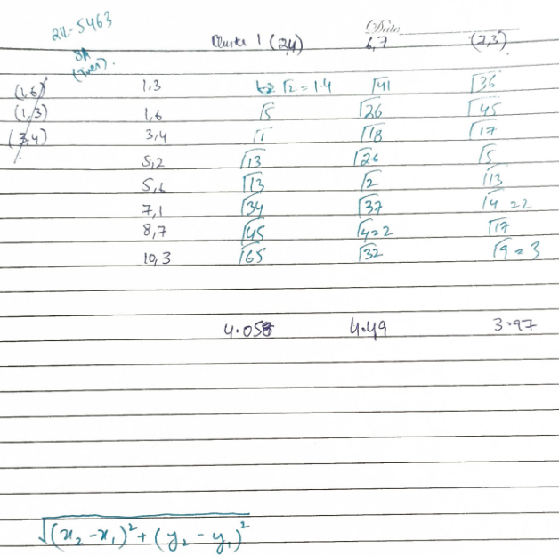

maxDistance (Data, Centers) = 3

Question 2:

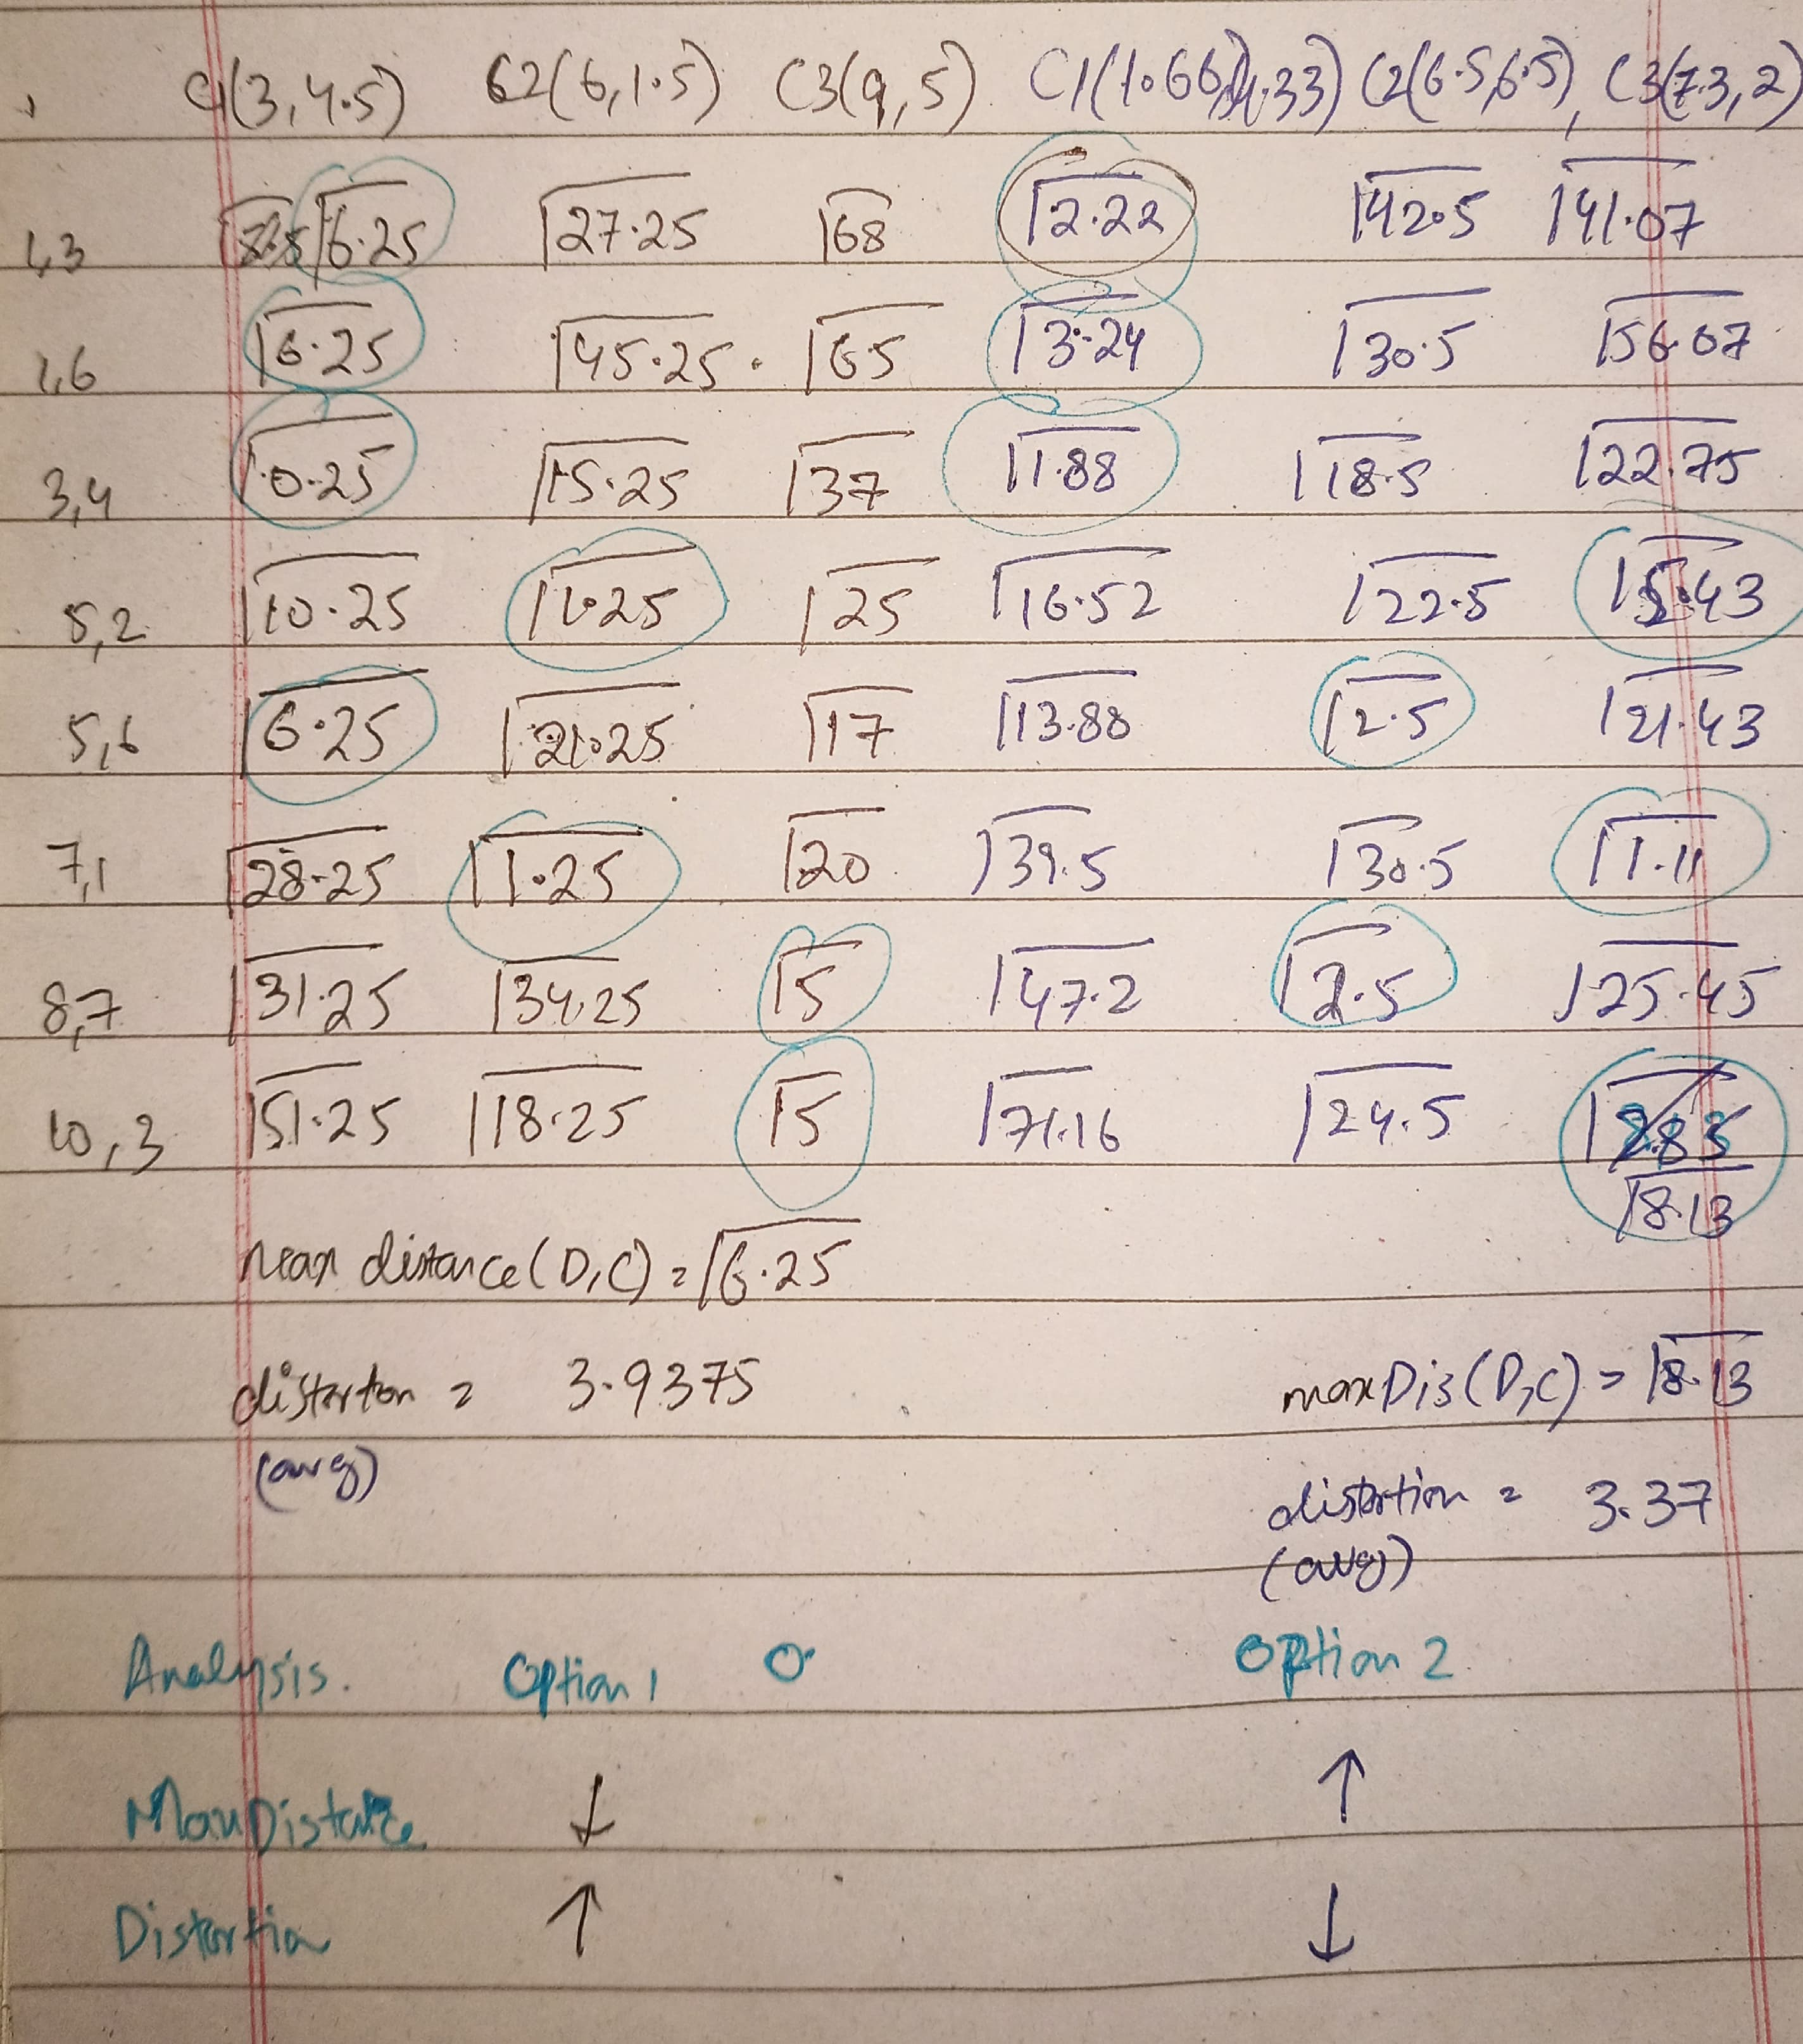

Question 3:

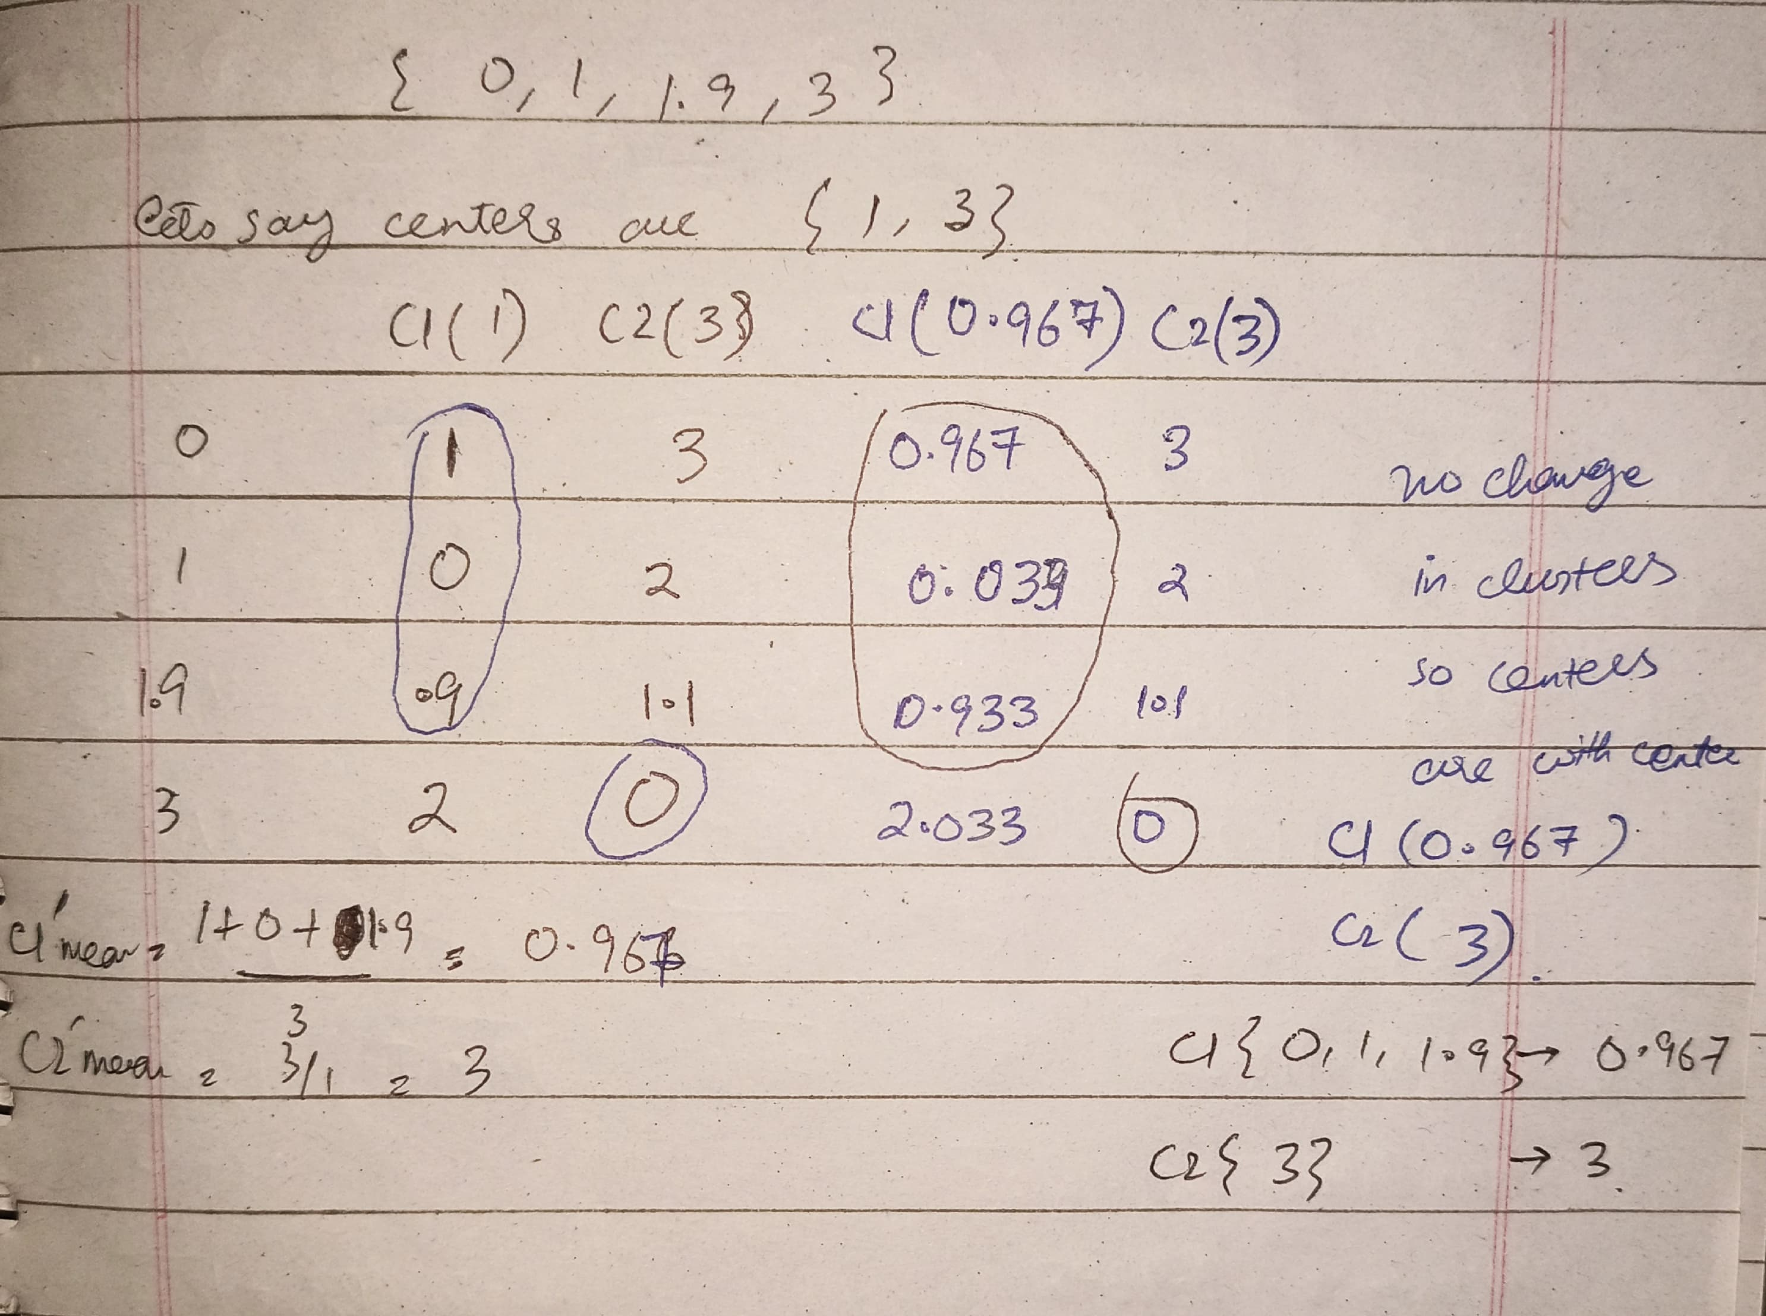

Question 4:

**Code**

import numpy as np

def print_clusters_and_matrix(clusters, dist_matrix, step, merge_info=None):

    print(f"\nStep {step}:")

    if merge_info:

        print(f"Merging clusters {merge_info[0]} and {merge_info[1]} with distance {merge_info[2]:.2f}")

    print("\nCurrent clusters:")

    for i, cluster in enumerate(clusters):

        print(f"Cluster {i+1}: {cluster}")

    print("\nDistance matrix:")

    header = "      " + "   ".join([f"C{i+1}" for i in range(len(clusters))])

    print(header)

    for i in range(len(clusters)):

        row = f"C{i+1}  " + "  ".join([f"{dist_matrix[i,j]:.2f}" for j in range(len(clusters))])

        print(row)

def hierarchical_clustering(distance_matrix, labels, linkage='average'):

    # Initialize

    current_dist = distance_matrix.copy()

    clusters = [[label] for label in labels]

    step = 0

    print(f"\nInitial distance matrix ({linkage} linkage):")

    print_clusters_and_matrix(clusters, current_dist, step)

    while len(clusters) > 1:

        step += 1

        # Find the two closest clusters

        min_dist = np.inf

        for i in range(len(clusters)):

            for j in range(i+1, len(clusters)):

                if current_dist[i,j] < min_dist:

                    min_dist = current_dist[i,j]

                    merge_i, merge_j = i, j

        # Merge the two closest clusters

        new_cluster = clusters[merge_i] + clusters[merge_j]

        merge_info = (clusters[merge_i], clusters[merge_j], min_dist)

        # Create new distance matrix

        new_clusters = [clusters[k] for k in range(len(clusters)) if k != merge_i and k != merge_j]

        new_clusters.append(new_cluster)

        new_dist = np.zeros((len(new_clusters), len(new_clusters)))

        # Fill in distances for existing clusters

        new_indices = {k: i for i, k in enumerate([idx for idx in range(len(clusters)) if idx != merge_i and idx != merge_j])}

        new_indices[merge_i] = len(new_clusters) - 1  # The merged cluster gets the last index

        # Copy unchanged distances

        for i in range(len(clusters)):

            for j in range(len(clusters)):

                if i != merge_i and i != merge_j and j != merge_i and j != merge_j:

                    new_i = new_indices[i]

                    new_j = new_indices[j]

                    new_dist[new_i, new_j] = current_dist[i,j]

        # Calculate new distances based on linkage method

        for k in range(len(clusters)):

            if k != merge_i and k != merge_j:

                if linkage == 'average':

                    # Average linkage calculation

                    total = 0

                    count = 0

                    for point_i in clusters[merge_i] + clusters[merge_j]:

                        for point_j in clusters[k]:

                            idx_i = labels.index(point_i)

                            idx_j = labels.index(point_j)

                            total += distance_matrix[idx_i, idx_j]

                            count += 1

                    avg_dist = total / count

                    new_dist_val = avg_dist

                elif linkage == 'single':

                    # Single linkage calculation (minimum distance)

                    min_d = np.inf

                    for point_i in clusters[merge_i] + clusters[merge_j]:

                        for point_j in clusters[k]:

                            idx_i = labels.index(point_i)

                            idx_j = labels.index(point_j)

                            if distance_matrix[idx_i, idx_j] < min_d:

                                min_d = distance_matrix[idx_i, idx_j]

                    new_dist_val = min_d

                new_k = new_indices[k]

                new_dist[len(new_clusters)-1, new_k] = new_dist_val

                new_dist[new_k, len(new_clusters)-1] = new_dist_val

        # Print current state

        print_clusters_and_matrix(new_clusters, new_dist, step, merge_info)

        # Update for next iteration

        clusters = new_clusters

        current_dist = new_dist

# Given distance matrix

labels = ['g1', 'g2', 'g3', 'g4', 'g5', 'g6', 'g7', 'g8', 'g9', 'g10']

distance_matrix = np.array([

    [0.0, 8.1, 9.2, 7.7, 9.3, 2.3, 5.1, 10.2, 6.1, 7.0],

    [8.1, 0.0, 12.0, 0.9, 12.0, 9.5, 10.1, 12.8, 2.0, 1.0],

    [9.2, 12.0, 0.0, 11.2, 0.7, 11.1, 8.1, 1.1, 10.5, 11.5],

    [7.7, 0.9, 11.2, 0.0, 11.2, 9.2, 9.5, 12.0, 1.6, 1.1],

    [9.3, 12.0, 0.7, 11.2, 0.0, 11.2, 8.5, 1.0, 10.6, 11.6],

    [2.3, 9.5, 11.1, 9.2, 11.2, 0.0, 5.6, 12.1, 7.7, 8.5],

    [5.1, 10.1, 8.1, 9.5, 8.5, 5.6, 0.0, 9.1, 8.3, 9.3],

    [10.2, 12.8, 1.1, 12.0, 1.0, 12.1, 9.1, 0.0, 11.4, 12.4],

    [6.1, 2.0, 10.5, 1.6, 10.6, 7.7, 8.3, 11.4, 0.0, 1.1],

    [7.0, 1.0, 11.5, 1.1, 11.6, 8.5, 9.3, 12.4, 1.1, 0.0]

])

# Run both linkage methods

print("="*80)

print("HIERARCHICAL CLUSTERING WITH AVERAGE LINKAGE")

print("="*80)

hierarchical_clustering(distance_matrix, labels, linkage='average')

print("\n" + "="*80)

print("HIERARCHICAL CLUSTERING WITH SINGLE LINKAGE")

print("="*80)

hierarchical_clustering(distance_matrix, labels, linkage='single')

**Output**

HIERARCHICAL CLUSTERING WITH AVERAGE LINKAGE

Initial distance matrix (average linkage):

Step 0:

Current clusters:

Cluster 1: ['g1']

Cluster 2: ['g2']

Cluster 3: ['g3']

Cluster 4: ['g4']

Cluster 5: ['g5']

Cluster 6: ['g6']

Cluster 7: ['g7']

Cluster 8: ['g8']

Cluster 9: ['g9']

Cluster 10: ['g10']

Distance matrix:

C1 C2 C3 C4 C5 C6 C7 C8 C9 C10

C1 0.00 8.10 9.20 7.70 9.30 2.30 5.10 10.20 6.10 7.00

C2 8.10 0.00 12.00 0.90 12.00 9.50 10.10 12.80 2.00 1.00

C3 9.20 12.00 0.00 11.20 0.70 11.10 8.10 1.10 10.50 11.50

C4 7.70 0.90 11.20 0.00 11.20 9.20 9.50 12.00 1.60 1.10

C5 9.30 12.00 0.70 11.20 0.00 11.20 8.50 1.00 10.60 11.60

C6 2.30 9.50 11.10 9.20 11.20 0.00 5.60 12.10 7.70 8.50

C7 5.10 10.10 8.10 9.50 8.50 5.60 0.00 9.10 8.30 9.30

C8 10.20 12.80 1.10 12.00 1.00 12.10 9.10 0.00 11.40 12.40

C9 6.10 2.00 10.50 1.60 10.60 7.70 8.30 11.40 0.00 1.10

C10 7.00 1.00 11.50 1.10 11.60 8.50 9.30 12.40 1.10 0.00

Step 1:

Merging clusters ['g3'] and ['g5'] with distance 0.70

Current clusters:

Cluster 1: ['g1']

Cluster 2: ['g2']

Cluster 3: ['g4']

Cluster 4: ['g6']

Cluster 5: ['g7']

Cluster 6: ['g8']

Cluster 7: ['g9']

Cluster 8: ['g10']

Cluster 9: ['g3', 'g5']

Distance matrix:

C1 C2 C3 C4 C5 C6 C7 C8 C9

C1 0.00 8.10 7.70 2.30 5.10 10.20 6.10 7.00 9.25

C2 8.10 0.00 0.90 9.50 10.10 12.80 2.00 1.00 12.00

C3 7.70 0.90 0.00 9.20 9.50 12.00 1.60 1.10 11.20

C4 2.30 9.50 9.20 0.00 5.60 12.10 7.70 8.50 11.15

C5 5.10 10.10 9.50 5.60 0.00 9.10 8.30 9.30 8.30

C6 10.20 12.80 12.00 12.10 9.10 0.00 11.40 12.40 1.05

C7 6.10 2.00 1.60 7.70 8.30 11.40 0.00 1.10 10.55

C8 7.00 1.00 1.10 8.50 9.30 12.40 1.10 0.00 11.55

C9 9.25 12.00 11.20 11.15 8.30 1.05 10.55 11.55 0.00

Step 2:

Merging clusters ['g2'] and ['g4'] with distance 0.90

Current clusters:

Cluster 1: ['g1']

Cluster 2: ['g6']

Cluster 3: ['g7']

Cluster 4: ['g8']

Cluster 5: ['g9']

Cluster 6: ['g10']

Cluster 7: ['g3', 'g5']

Cluster 8: ['g2', 'g4']

Distance matrix:

C1 C2 C3 C4 C5 C6 C7 C8

C1 0.00 2.30 5.10 10.20 6.10 7.00 9.25 7.90

C2 2.30 0.00 5.60 12.10 7.70 8.50 11.15 9.35

C3 5.10 5.60 0.00 9.10 8.30 9.30 8.30 9.80

C4 10.20 12.10 9.10 0.00 11.40 12.40 1.05 12.40

C5 6.10 7.70 8.30 11.40 0.00 1.10 10.55 1.80

C6 7.00 8.50 9.30 12.40 1.10 0.00 11.55 1.05

C7 9.25 11.15 8.30 1.05 10.55 11.55 0.00 11.60

C8 7.90 9.35 9.80 12.40 1.80 1.05 11.60 0.00

Step 3:

Merging clusters ['g8'] and ['g3', 'g5'] with distance 1.05

Current clusters:

Cluster 1: ['g1']

Cluster 2: ['g6']

Cluster 3: ['g7']

Cluster 4: ['g9']

Cluster 5: ['g10']

Cluster 6: ['g2', 'g4']

Cluster 7: ['g8', 'g3', 'g5']

Distance matrix:

C1 C2 C3 C4 C5 C6 C7

C1 0.00 2.30 5.10 6.10 7.00 7.90 9.57

C2 2.30 0.00 5.60 7.70 8.50 9.35 11.47

C3 5.10 5.60 0.00 8.30 9.30 9.80 8.57

C4 6.10 7.70 8.30 0.00 1.10 1.80 10.83

C5 7.00 8.50 9.30 1.10 0.00 1.05 11.83

C6 7.90 9.35 9.80 1.80 1.05 0.00 11.87

C7 9.57 11.47 8.57 10.83 11.83 11.87 0.00

Step 4:

Merging clusters ['g10'] and ['g2', 'g4'] with distance 1.05

Current clusters:

Cluster 1: ['g1']

Cluster 2: ['g6']

Cluster 3: ['g7']

Cluster 4: ['g9']

Cluster 5: ['g8', 'g3', 'g5']

Cluster 6: ['g10', 'g2', 'g4']

Distance matrix:

C1 C2 C3 C4 C5 C6

C1 0.00 2.30 5.10 6.10 9.57 7.60

C2 2.30 0.00 5.60 7.70 11.47 9.07

C3 5.10 5.60 0.00 8.30 8.57 9.63

C4 6.10 7.70 8.30 0.00 10.83 1.57

C5 9.57 11.47 8.57 10.83 0.00 11.86

C6 7.60 9.07 9.63 1.57 11.86 0.00

Step 5:

Merging clusters ['g9'] and ['g10', 'g2', 'g4'] with distance 1.57

Current clusters:

Cluster 1: ['g1']

Cluster 2: ['g6']

Cluster 3: ['g7']

Cluster 4: ['g8', 'g3', 'g5']

Cluster 5: ['g9', 'g10', 'g2', 'g4']

Distance matrix:

C1 C2 C3 C4 C5

C1 0.00 2.30 5.10 9.57 7.22

C2 2.30 0.00 5.60 11.47 8.72

C3 5.10 5.60 0.00 8.57 9.30

C4 9.57 11.47 8.57 0.00 11.60

C5 7.22 8.72 9.30 11.60 0.00

Step 6:

Merging clusters ['g1'] and ['g6'] with distance 2.30

Current clusters:

Cluster 1: ['g7']

Cluster 2: ['g8', 'g3', 'g5']

Cluster 3: ['g9', 'g10', 'g2', 'g4']

Cluster 4: ['g1', 'g6']

Distance matrix:

C1 C2 C3 C4

C1 0.00 8.57 9.30 5.35

C2 8.57 0.00 11.60 10.52

C3 9.30 11.60 0.00 7.97

C4 5.35 10.52 7.97 0.00

Step 7:

Merging clusters ['g7'] and ['g1', 'g6'] with distance 5.35

Current clusters:

Cluster 1: ['g8', 'g3', 'g5']

Cluster 2: ['g9', 'g10', 'g2', 'g4']

Cluster 3: ['g7', 'g1', 'g6']

Distance matrix:

C1 C2 C3

C1 0.00 11.60 9.87

C2 11.60 0.00 8.42

C3 9.87 8.42 0.00

Step 8:

Merging clusters ['g9', 'g10', 'g2', 'g4'] and ['g7', 'g1', 'g6'] with distance 8.42

Current clusters:

Cluster 1: ['g8', 'g3', 'g5']

Cluster 2: ['g9', 'g10', 'g2', 'g4', 'g7', 'g1', 'g6']

Distance matrix:

C1 C2

C1 0.00 10.86

C2 10.86 0.00

Step 9:

Merging clusters ['g8', 'g3', 'g5'] and ['g9', 'g10', 'g2', 'g4', 'g7', 'g1', 'g6'] with distance 10.86

Current clusters:

Cluster 1: ['g8', 'g3', 'g5', 'g9', 'g10', 'g2', 'g4', 'g7', 'g1', 'g6']

Distance matrix:

C1

C1 0.00

================================================================================

HIERARCHICAL CLUSTERING WITH SINGLE LINKAGE

================================================================================

Initial distance matrix (single linkage):

Step 0:

Current clusters:

Cluster 1: ['g1']

Cluster 2: ['g2']

Cluster 3: ['g3']

Cluster 4: ['g4']

Cluster 5: ['g5']

Cluster 6: ['g6']

Cluster 7: ['g7']

Cluster 8: ['g8']

Cluster 9: ['g9']

Cluster 10: ['g10']

Distance matrix:

C1 C2 C3 C4 C5 C6 C7 C8 C9 C10

C1 0.00 8.10 9.20 7.70 9.30 2.30 5.10 10.20 6.10 7.00

C2 8.10 0.00 12.00 0.90 12.00 9.50 10.10 12.80 2.00 1.00

C3 9.20 12.00 0.00 11.20 0.70 11.10 8.10 1.10 10.50 11.50

C4 7.70 0.90 11.20 0.00 11.20 9.20 9.50 12.00 1.60 1.10

C5 9.30 12.00 0.70 11.20 0.00 11.20 8.50 1.00 10.60 11.60

C6 2.30 9.50 11.10 9.20 11.20 0.00 5.60 12.10 7.70 8.50

C7 5.10 10.10 8.10 9.50 8.50 5.60 0.00 9.10 8.30 9.30

C8 10.20 12.80 1.10 12.00 1.00 12.10 9.10 0.00 11.40 12.40

C9 6.10 2.00 10.50 1.60 10.60 7.70 8.30 11.40 0.00 1.10

C10 7.00 1.00 11.50 1.10 11.60 8.50 9.30 12.40 1.10 0.00

Step 1:

Merging clusters ['g3'] and ['g5'] with distance 0.70

Current clusters:

Cluster 1: ['g1']

Cluster 2: ['g2']

Cluster 3: ['g4']

Cluster 4: ['g6']

Cluster 5: ['g7']

Cluster 6: ['g8']

Cluster 7: ['g9']

Cluster 8: ['g10']

Cluster 9: ['g3', 'g5']

Distance matrix:

C1 C2 C3 C4 C5 C6 C7 C8 C9

C1 0.00 8.10 7.70 2.30 5.10 10.20 6.10 7.00 9.20

C2 8.10 0.00 0.90 9.50 10.10 12.80 2.00 1.00 12.00

C3 7.70 0.90 0.00 9.20 9.50 12.00 1.60 1.10 11.20

C4 2.30 9.50 9.20 0.00 5.60 12.10 7.70 8.50 11.10

C5 5.10 10.10 9.50 5.60 0.00 9.10 8.30 9.30 8.10

C6 10.20 12.80 12.00 12.10 9.10 0.00 11.40 12.40 1.00

C7 6.10 2.00 1.60 7.70 8.30 11.40 0.00 1.10 10.50

C8 7.00 1.00 1.10 8.50 9.30 12.40 1.10 0.00 11.50

C9 9.20 12.00 11.20 11.10 8.10 1.00 10.50 11.50 0.00

Step 2:

Merging clusters ['g2'] and ['g4'] with distance 0.90

Current clusters:

Cluster 1: ['g1']

Cluster 2: ['g6']

Cluster 3: ['g7']

Cluster 4: ['g8']

Cluster 5: ['g9']

Cluster 6: ['g10']

Cluster 7: ['g3', 'g5']

Cluster 8: ['g2', 'g4']

Distance matrix:

C1 C2 C3 C4 C5 C6 C7 C8

C1 0.00 2.30 5.10 10.20 6.10 7.00 9.20 7.70

C2 2.30 0.00 5.60 12.10 7.70 8.50 11.10 9.20

C3 5.10 5.60 0.00 9.10 8.30 9.30 8.10 9.50

C4 10.20 12.10 9.10 0.00 11.40 12.40 1.00 12.00

C5 6.10 7.70 8.30 11.40 0.00 1.10 10.50 1.60

C6 7.00 8.50 9.30 12.40 1.10 0.00 11.50 1.00

C7 9.20 11.10 8.10 1.00 10.50 11.50 0.00 11.20

C8 7.70 9.20 9.50 12.00 1.60 1.00 11.20 0.00

Step 3:

Merging clusters ['g8'] and ['g3', 'g5'] with distance 1.00

Current clusters:

Cluster 1: ['g1']

Cluster 2: ['g6']

Cluster 3: ['g7']

Cluster 4: ['g9']

Cluster 5: ['g10']

Cluster 6: ['g2', 'g4']

Cluster 7: ['g8', 'g3', 'g5']

Distance matrix:

C1 C2 C3 C4 C5 C6 C7

C1 0.00 2.30 5.10 6.10 7.00 7.70 9.20

C2 2.30 0.00 5.60 7.70 8.50 9.20 11.10

C3 5.10 5.60 0.00 8.30 9.30 9.50 8.10

C4 6.10 7.70 8.30 0.00 1.10 1.60 10.50

C5 7.00 8.50 9.30 1.10 0.00 1.00 11.50

C6 7.70 9.20 9.50 1.60 1.00 0.00 11.20

C7 9.20 11.10 8.10 10.50 11.50 11.20 0.00

Step 4:

Merging clusters ['g10'] and ['g2', 'g4'] with distance 1.00

Current clusters:

Cluster 1: ['g1']

Cluster 2: ['g6']

Cluster 3: ['g7']

Cluster 4: ['g9']

Cluster 5: ['g8', 'g3', 'g5']

Cluster 6: ['g10', 'g2', 'g4']

Distance matrix:

C1 C2 C3 C4 C5 C6

C1 0.00 2.30 5.10 6.10 9.20 7.00

C2 2.30 0.00 5.60 7.70 11.10 8.50

C3 5.10 5.60 0.00 8.30 8.10 9.30

C4 6.10 7.70 8.30 0.00 10.50 1.10

C5 9.20 11.10 8.10 10.50 0.00 11.20

C6 7.00 8.50 9.30 1.10 11.20 0.00

Step 5:

Merging clusters ['g9'] and ['g10', 'g2', 'g4'] with distance 1.10

Current clusters:

Cluster 1: ['g1']

Cluster 2: ['g6']

Cluster 3: ['g7']

Cluster 4: ['g8', 'g3', 'g5']

Cluster 5: ['g9', 'g10', 'g2', 'g4']

Distance matrix:

C1 C2 C3 C4 C5

C1 0.00 2.30 5.10 9.20 6.10

C2 2.30 0.00 5.60 11.10 7.70

C3 5.10 5.60 0.00 8.10 8.30

C4 9.20 11.10 8.10 0.00 10.50

C5 6.10 7.70 8.30 10.50 0.00

Step 6:

Merging clusters ['g1'] and ['g6'] with distance 2.30

Current clusters:

Cluster 1: ['g7']

Cluster 2: ['g8', 'g3', 'g5']

Cluster 3: ['g9', 'g10', 'g2', 'g4']

Cluster 4: ['g1', 'g6']

Distance matrix:

C1 C2 C3 C4

C1 0.00 8.10 8.30 5.10

C2 8.10 0.00 10.50 9.20

C3 8.30 10.50 0.00 6.10

C4 5.10 9.20 6.10 0.00

Step 7:

Merging clusters ['g7'] and ['g1', 'g6'] with distance 5.10

Current clusters:

Cluster 1: ['g8', 'g3', 'g5']

Cluster 2: ['g9', 'g10', 'g2', 'g4']

Cluster 3: ['g7', 'g1', 'g6']

Distance matrix:

C1 C2 C3

C1 0.00 10.50 8.10

C2 10.50 0.00 6.10

C3 8.10 6.10 0.00

Step 8:

Merging clusters ['g9', 'g10', 'g2', 'g4'] and ['g7', 'g1', 'g6'] with distance 6.10

Current clusters:

Cluster 1: ['g8', 'g3', 'g5']

Cluster 2: ['g9', 'g10', 'g2', 'g4', 'g7', 'g1', 'g6']

Distance matrix:

C1 C2

C1 0.00 8.10

C2 8.10 0.00

Step 9:

Merging clusters ['g8', 'g3', 'g5'] and ['g9', 'g10', 'g2', 'g4', 'g7', 'g1', 'g6'] with distance 8.10

Current clusters:

Cluster 1: ['g8', 'g3', 'g5', 'g9', 'g10', 'g2', 'g4', 'g7', 'g1', 'g6']

Distance matrix:

C1

C1 0.00